Table of Contents
- Overview
- Setup & Installation
- Exploratory Data Analysis (EDA) & Modeling
- Experiment Tracking Summary
- REST API & Usage
- Architecture Diagram
- CI/CD & Deployment Workflow
- Repository Structure

Overview:
Problem Statement
Build a reliable classifier to predict heart disease risk using structured patient health data (e.g., age, cholesterol, blood pressure), automatically track experiments, and deploy as a production API.
Key Features:
- Data pipeline with preprocessing
- Model training with comparison and tracking
- MLflow integration
- FastAPI REST API for predictions
- Docker & CI/CD pipelines
- Unit & integration test coverage

Setup / Installation:
Prerequisites
Ensure these tools are installed:
- Python 3.9+ (3.11 recommended)
- Docker (optional, for containerization)
- Make (optional but recommended)
- Git

Clone & Create Environment:
git clone https://github.com/deb-sahu/heart-disease-predictor.git
cd heart-disease-predictor
python3 -m venv venv
source venv/bin/activate

Install Dependencies:
git clone https://github.com/deb-sahu/heart-disease-predictor.git
cd heart-disease-predictor

python3 -m venv venv
source venv/bin/activate

EDA and Modelling Choices:
Dataset
- Source: UCI Heart Disease dataset
- Size: 303 samples
- Features: 13 clinical features (e.g., age, sex, bp, chol, etc.)
- Target: Binary (presence/absence of heart disease)

Preprocessing
- Missing value handling
- Feature scaling and encoding
- Train/test split
- Potential multicollinearity checks

Models Evaluated
- Logistic Regression
- Random Forest Classifier

Experiment Tracking Summary:
MLflow is used to track metrics, hyperparameters, and artifacts such as:
Metric | Description
Accuracy | Overall classification accuracy
Precision | Correct positive predictions
Recall | Sensitivity of detection
F1 Score | Harmonic Mean of precision/recall
ROC-AUC | Model discrimination capability

Artifacts Logged:
- Confusion matrix plots
- ROC curve plots
- Classification reports
- Model files

View Experiments:
mlflow ui --port 5000

python3 -m venv venv
source venv/bin/activate

Then open: http://localhost:5000

REST API Usage:
The project exposes a FastAPI service.
Run API
make run
# OR
uvicorn api.app:app --reload --port 8000

python3 -m venv venv
source venv/bin/activate

Example Request
curl -X POST http://localhost:8000/predict \
-H "Content-Type: application/json" \
-d '{"age":63,"sex":1,...,"thal":1}'

python3 -m venv venv
source venv/bin/activate

Endpoints
Endpoint | Method | Purpose
/ | GET | API health/info
/health | GET | Health check
/predict | POST | Make prediction
/model/info | GET | Model metadata

Architecture Diagram:

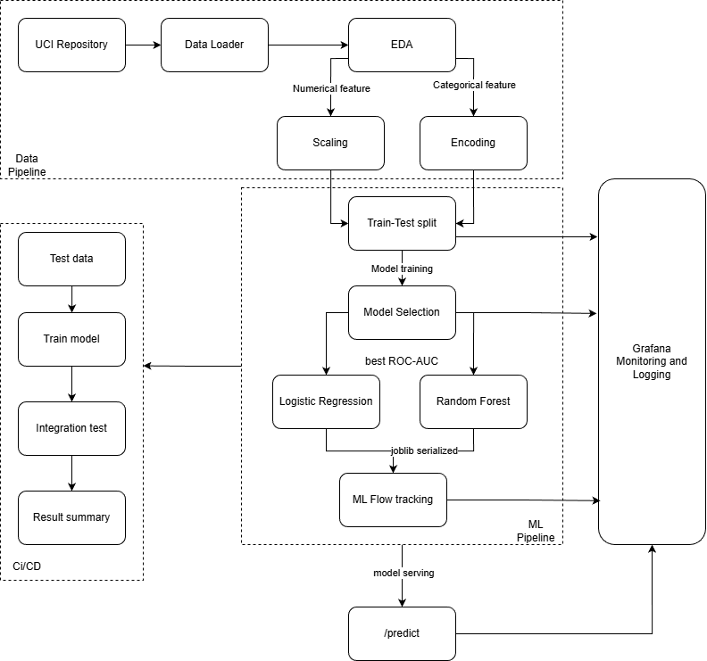

CI/CD and Deployment Workflow:
The repository includes a GitHub Actions pipeline defined in:
.github/workflows/ci-cd.yml

The pipeline stages include:

- Linting & Formatting
- Unit & Integration Testing
- Model Training
- Docker Image Build
- Integration Tests
- Deployment Triggers on Push/PR to Main/Master

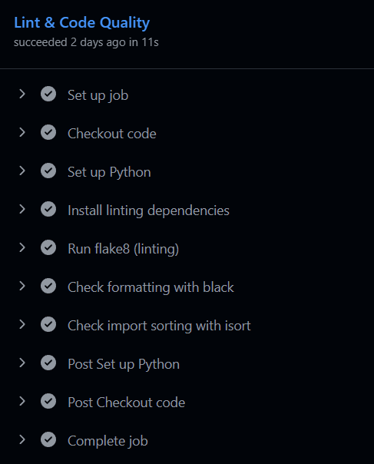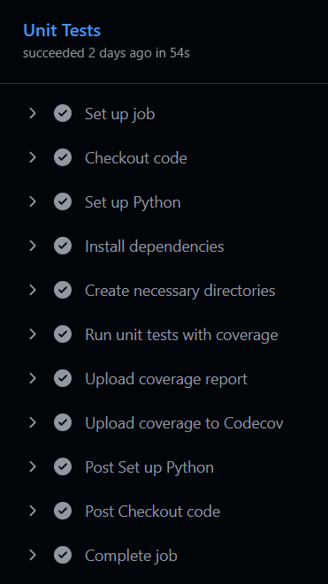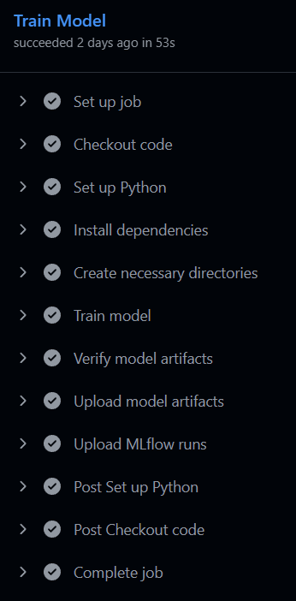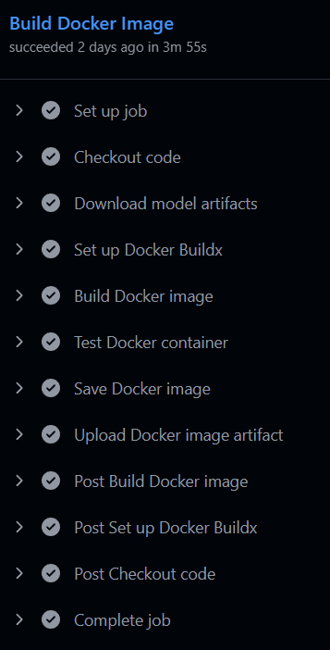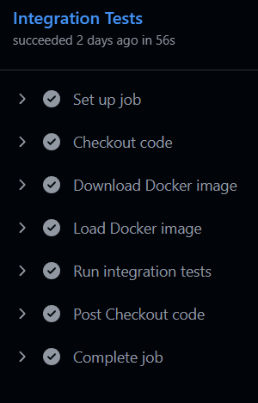
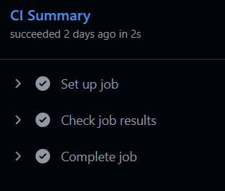

Repository Structure:
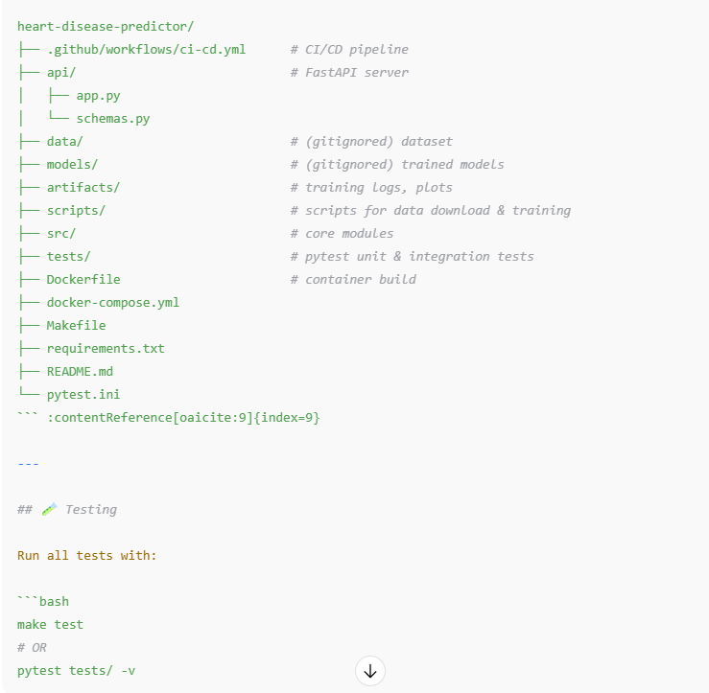

Code repository:
https://github.com/deb-sahu/heart-disease-predictor

